Syam Daswani MI122

Furniture Business
History

A furniture company was established in 1960 in Houston Texas. The founder, Bobby Anderson, came to the U.S from Europe to continue creating furniture with his family. He, like his ancestors, enjoyed designing and making furniture so that people could enjoy his creations. Although the company has grown over the years, it has always stayed true to Bobby Anderson's original vision of producing hand-crafted, creative furniture that can be enjoyed for generations to come.
Mission

The Furniture Company's mission is to provide high quality, unique, one-of-a-kind furniture for everyone to enjoy.
Vision

As the Furniture Company continues to grow and expand, we want to continue making furniture that many peole will enjoy. In the future we hope that our business will grow to be very successful.

Project Case

- The company sells a number of different furniture products. These products are grouped into several product lines. The identifier for a product is Product_ID, while the identifier for a product line is Product_Line_ID. Referring to the customer invoice, we identify the following additional attributes for product: Product_Description, Product_Finish, and Unit_Price. Another attribute fro product line is Product_Line_Name. A product line may group any number of products, but must group at least one product. Each product must belong to exactly one product line.

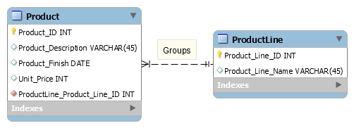

- Customers submit orders for products The identifier from an order is Order-ID, and another attribute is Order_Date. A customer may submit any number of orders, but need not submit any orders. Each order is submitted by exactly one customer. The identifier for a customer is Customer_ID. Other attributes include Customer_Name and Customer_Address.

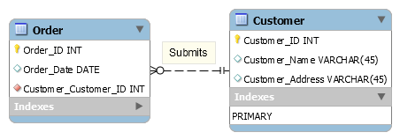

- A given customer order must request at least one product. Any product sold by the Furniture Company may not be requested on any order, or may be requested on one or more orders. An attribute associated with each order and product is Quantity, which is the number of units requested.

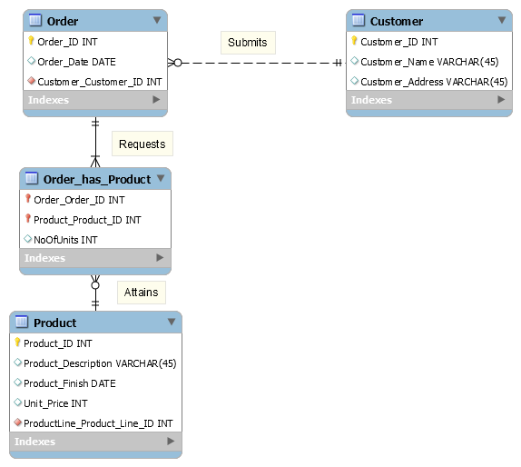

- The Furniture Company has established sales territories for its customers. Each customer does business in one or more of these sales territories. The identifier for a sales territory is Territory_ID. A sales territory may have any number of customers, or may not have any customers doing business.
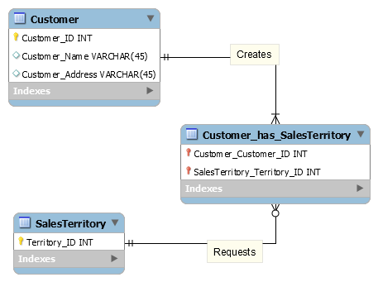

- The Furniture Company has several salespersons. The identifier for a salesperson is Salesperson_ID. Other attributes include Salesperson_Name, Salesperson_Telephone, and Salesperson_Fax. A salesperson serves exactly one sales territory. Each sales territory is served by one or more salespersons.

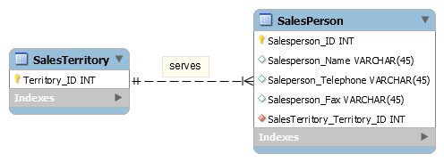

- Each product is assembled from one or more raw materials. The identifier for the raw material entity is Material_ID. Other attributes include Unit_of_Measure and Unit_Price. Each raw material may be assembled into one or more products.

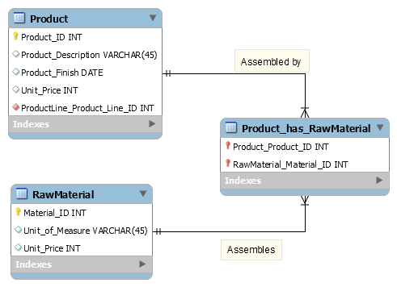

- Raw materials are supplied by vendors. The identifier for a vendor is Vendor_ID. Other attributes include Vendor_Name and Vendor_Address. Each raw material can be supplied by one or more vendors. A vendor may supply any number of raw materials, or may not supply any raw materials to the Furniture Company. An attribute of the relationship between vendor and raw material is Unit_Price

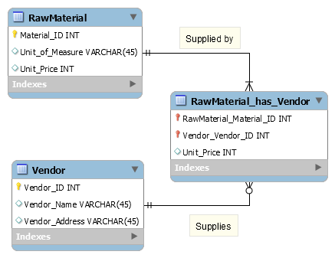

- The Furniture Company has established a number of work centers. The identifier for a work center is Work_Center_ID. Another attribute is Location. Each product is produced in one or more work centers. A work center may be used to produce any number of products, or may not be used to produce any products.

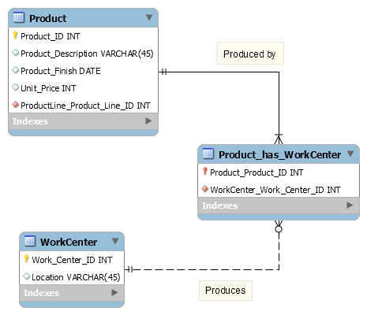

- The company has over 100 employees. The identifier for employee is Employee_ID. Other attributes are Employee_Name, EmployeeAddress, and Sill. An employee may have more than one skill. And Each skill can be mastered by many employees or none.

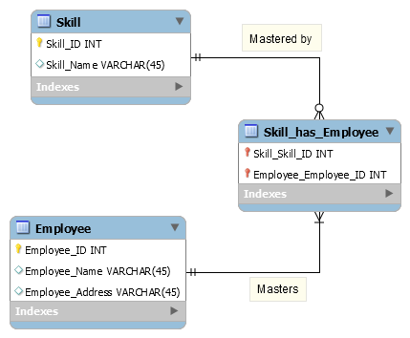

- Each employee works in one or more work centers. A work center must have at least one employee working in that center, but may have any number of employees.

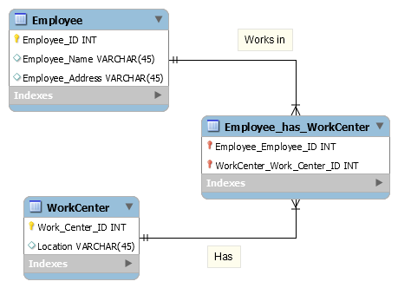

- Each employee has exactly one supervisor. An employee who is a supervisor may supervise any number of employees, but not all employees are supervisors.

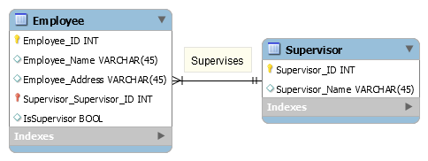

OVERALL ERD:

